**Assignment 6 – Multithreaded Web Server Using Rust**

By – Viveka Kumar (J01258735)

**Objective:**

To implement a basic yet functional **multithreaded web server** in Rust, which demonstrates:

* TCP Socket Programming
* Basic HTTP parsing
* Serving static HTML pages
* Managing concurrency using a **custom thread pool**
* Graceful shutdown and cleanup of threads

**Steps followed and features implemented**

Creating a new project as in rust as – “assignment*6 “*

* Listening to TCP Port - Adding the **TCPListener** that will listen to at the local address 127.0.0.1:7878 for incoming TCP streams in main.rs file

Code line: 

Output:

* Accepting incoming connections and handling them in a thread pool:

Code line:

* Reading the HTTPS Request

Code Lines:

* Now we are Returning HTTP Responses, using the routing logic on URL & writing the response to the stream (stream.write_all)

Code Lines:

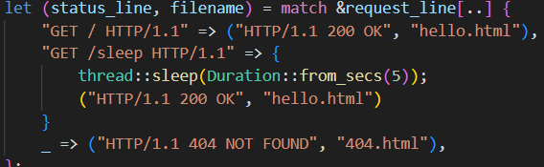

* Thread Pool Implementation in “ lib.rs ” – using “impl Treadpool”

* Implementing **Graceful Shutdown of Threads** in lib.rs :

* Worker thread managing sender and exiting loop when needed:

**Terminal Output:**

**Web Results**

* **Display page Code – hello.html**

Output:

* **Error message Display – 404.html**

Code:

Output:

**Appendix:**

